TITLE OF THE ARTICLE IN ENGLISH
TWO ROWS MAXIMUM

FULL First Author^{1, a *}, FULL Second Author^{2,b} and FULL Last Author^{3,c}

Abstract:
This paper deals with the possibilities of using recycled glass from fluorescent lamps for production elements based on sintered glass. It can be stated that these materials are relatively new and progressive. Taking into account that the recycled glass finds no further use for re-production of new materials it is a fairly topical problems. At present there is only one ……… A single paragraph of about 200 words maximum

Keywords: keyword 1; keyword2; keyword 3 (in English; separated by semicolon).

1. Introduction
In this chapter, summarise the current state of knowledge; references to the literature used should be given in the chapter on the literature used. References should be numbered in square brackets.

2. Materials ans Methods
This chapter should describe the characteristics of the test materials and the tests to be made on the samples.
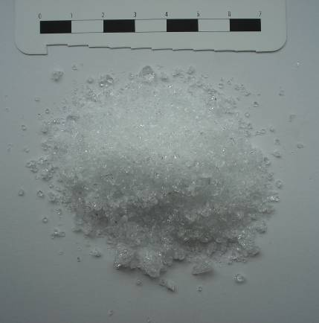 | 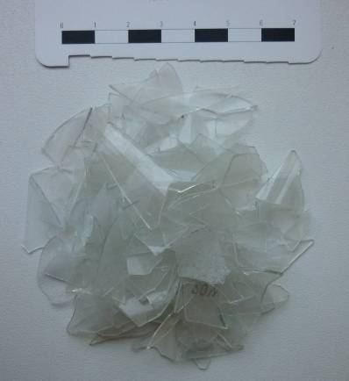
(a) | (b)
Figure 1: Used materials: (a) reference sample, borosilicate, (b) glass from recycled fluorescent lamps.

Table 1: Chemical composition of fluorescent glass - comparison with borosilicate glass
Chemical component | Material
Chemical component | REF [%] | ZAR [%]
SiO₂ | 72.01 | 71.7
Al₂O₃ | 7.11 | 2.15
Fe₂O₃ | - | 0.12
BaO | 1.98 | 0.32
CaO | 1.05 | 4.63
B₂O₃ | 10.24 | < 0.01
MgO | - | 3.02
Na₂O | 6.22 | 16.9
K₂O | 2.02 | 1.02
P₂O₅ | - | < 0.01
ZnO | - | < 0.01
Hg | - | < 0.000005

The particle size distribution of the granules under investigation, i.e. reference glass and fluorescent glass, was determined by analysing the feedstock. The results of the determination of the granulometric composition of the investigated shards can be seen in the following figure (see Fig. 2).
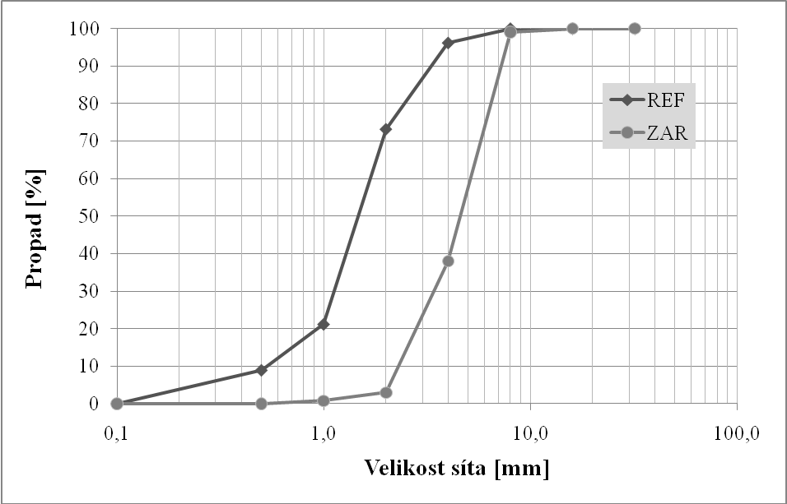
Figure 2: Results of the particle size distribution of the input raw materials (REF - borosilicate glass, ZAR - recycled glass from fluorescent lamps)
If you need to insert an equation, use the equation editor. There should be one line of space above the equation and one line of space below it before the text continues. The equations have to be numbered sequentially, and the number put in parentheses at the right-hand edge of the text.
(1)

3. Results
This section may be divided by subheadings. It should provide a concise and precise description of the experimental results, their interpretation, as well as the experimental conclusions that can be drawn.

3.1. Subsection

3.1.1. Subsubsection
Bulleted lists look like this:
- First bullet;
- Second bullet;
- Third bullet.

Numbered lists can be added as follows:
- First item;
- Second item;
- Third item.
The text continues here.

3.2. Figures, Tables and Schemes
All figures and tables should be cited in the main text as Figure 1, Table 1, etc.

4. Discussion
Authors should discuss the results and how they can be interpreted from the perspective of previous studies and of the working hypotheses. The findings and their implications should be discussed in the broadest context possible. Future research directions may also be highlighted

5. Conclusion
Based on the measurements and analyses of the basic physical, mechanical and chemical parameters, it can be concluded that...

5. References
[1] Author 1, A.B.; Author 2, C.D. Title of the article. Abbreviated Journal Name Year, Volume, page range.
[2] Author 1, A.; Author 2, B. Title of the chapter. In Book Title, 2nd ed.; Editor 1, A., Editor 2, B., Eds.; Publisher: Publisher Location, Country, 2007; Volume 3, pp. 154–196.
[3] Title of Site. Available online: URL (accessed on Day Month Year).
[4] J. van der Geer, J.A.J. Hanraads, R.A. Lupton, The art of writing a scientific article, J. Sci. Commun. 163 (2000) 51-59.
[5] W. Strunk Jr., E.B. White, The Elements of Style, third ed., Macmillan, New York, 1979.
[6] G.R. Mettam, L.B. Adams, How to prepare an electronic version of your article, in: B.S. Jones, R.Z. Smith (Eds.), Introduction to the Electronic Age, E-Publishing Inc., New York, 1999, pp. 281-304.
[7] R.J. Ong, J.T. Dawley and P.G. Clem: submitted to Journal of Materials Research (2003)
[8] P.G. Clem, M. Rodriguez, J.A. Voigt and C.S. Ashley, U.S. Patent 6,231,666. (2001)

Authors:
prof. Ing. Josef Novák, DrSc. – Brno University of Technology, Faculty of Civil Enginenring, Institute of Building Materials and Components, Veveří 331/95, 60200 Brno, Czech Republic. e-mail: xyz@xyz.cz

Acknowledgements
This research has been realized with financial support from the state budget through the Ministry of Industry and Trade within the project FT-TAX/XXX "Project Title".

Recommended length: 4 – 10 pages.

